Using the Portal

We are happy to provide you with access to your insurance information anytime via the web. By now you should have received an invitation email with information to activate your Portal account. The email looks similar to the one below:

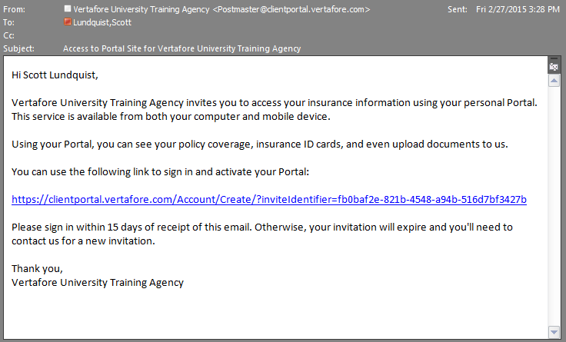

Use the link in the email to open and activate your account for the Portal. If you haven’t received the email* or you didn’t activate the account within 15 days of receiving the email, contact us for a new account activation email.

*\*If you haven’t received the email in your Inbox, check your Junk email folder.*

## What You Can See and Do in the Portal?

You can access the Portal on your desktop computer, smart phone, or tablet providing you with flexibility. The Portal contains tabs of information that include an Overview, Policies, Auto ID Cards, Claims, Documents, and Certificates.

*What you see may differ depending on your permissions.*

The Overview tab displays your Quick Links, announcements from your agency, recent documents, and a list of your agency contacts.

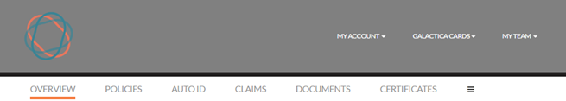

### The Policies Tab

The policies tab displays all of your current and future policies. Each policy includes the policy number, the type of business (such as Homeowners or Private Passenger), and the policy term, an icon for the insurance company providing the coverage, and a View Summary link, a link to a pdf file, or a Not yet available notation.

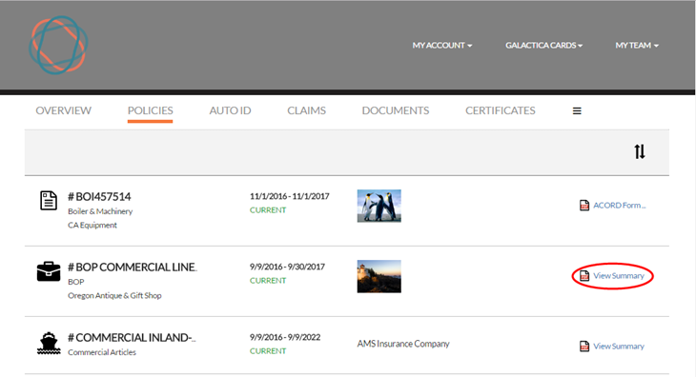

Click the **View Summary** link to see the details of the policy similar to the following example:

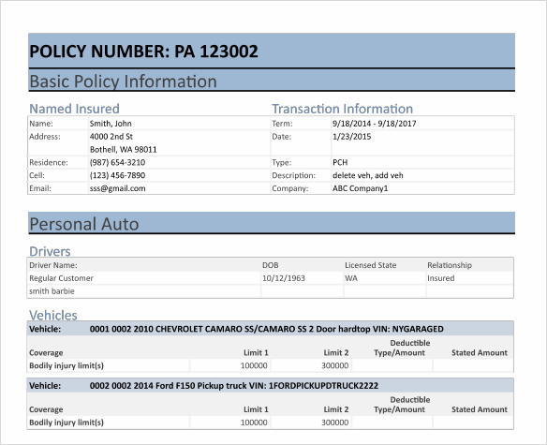

To request a change to the policy do the following:

1. Click the policy in the grid.
2. When the Policy Summary page loads, scroll to the bottom of the page and click **Request a Change**.  
     
   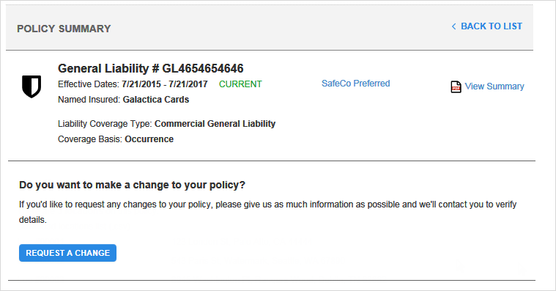
3. On the Request Policy Change window, enter the change you’d like to make. Whether it’s to add/remove a driver or increase/decrease coverage limits. Complete the other information and when you’re finished click **Submit**.

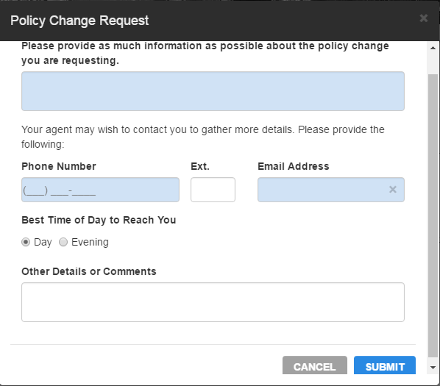

A follow up is sent to our agency.

The change request date and status appear on the Policy Summary page. A member of our staff will process the change and let you know when it’s done.

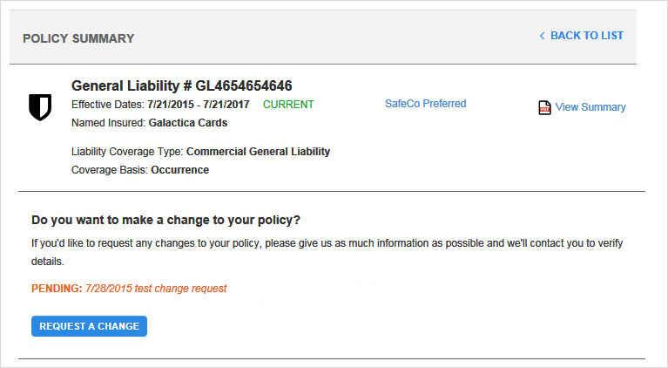

### The Auto ID Tab

Your current auto policies are examined for vehicles insured on the policy. When a vehicle is found it appears on the Auto ID tab. On this tab you can view, download, email, and print an Auto ID card for a policy.

Being able to view online is handy if you need your Auto ID card, but don’t have it with you. You can use your smart phone or tablet to access the Portal and produce an electronic copy of your card.

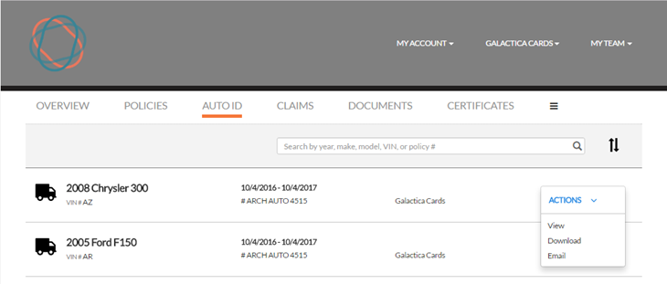

### The Claims Tab

On this tab you can view claims entered by our agency as well as submit a claim.

*Based on your permissions you may or may not be able to enter a new claim.*

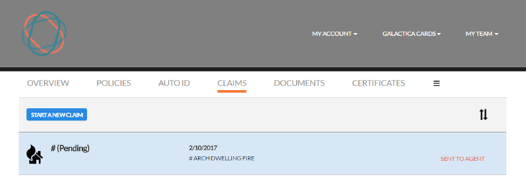

Do the following to submit a claim:

1. On the Claims tab click **Start a New Claim**.
2. The first thing you need to do is choose the policy for which you are filing the claim.  
   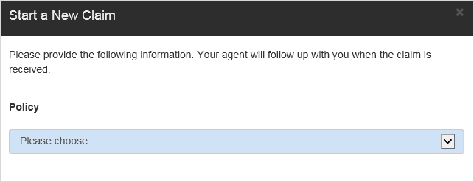
3. Complete the fields on the Claim form. Some selections you choose from a list while others you type in the information.  
   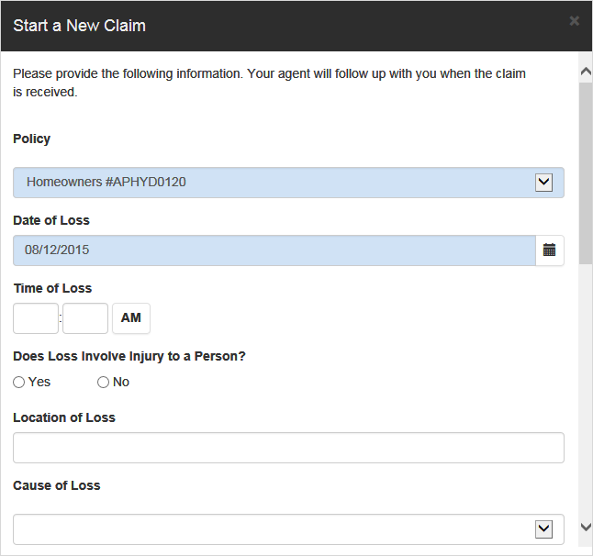
4. When you have finished entering all the information, click **Submit**.  
   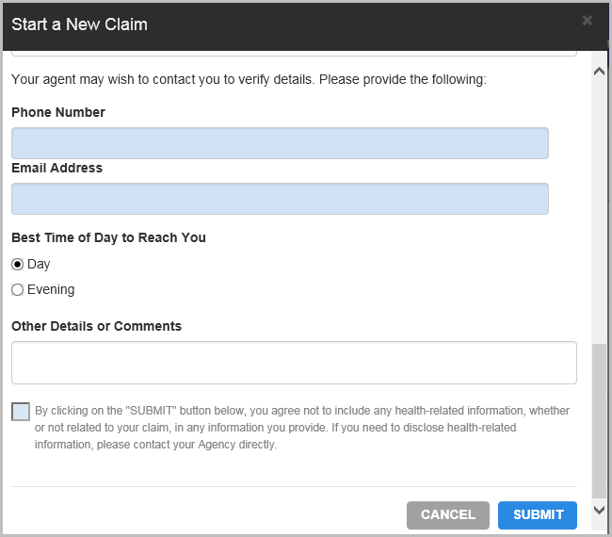
5. After entering the claim you’ll see the claim you’ve entered with a status of Pending and a notation of Sent to Agent.
6. When your claim has been reviewed by our staff, the status changes to Open.

### The Documents Tab

On the Documents tab you’ll see documents we have shared with you as well as any you have uploaded to the Portal. The documents are stored in a secure encrypted form.

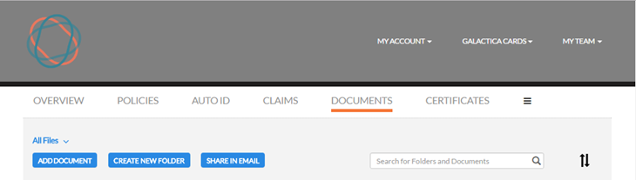

Use the Actions drop-down to open, move, rename, delete, or Share a link to the document in an email.

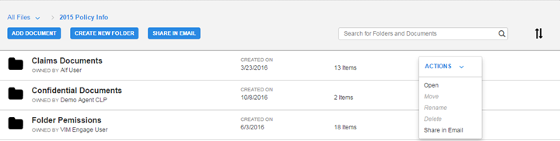

To add a document, click **Add Document** above the document list.

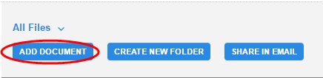

Some folders may require you to have certain permissions in order to access their contents. These folders will be marked restricted. Use the Actions drop-down to request access to the folder.

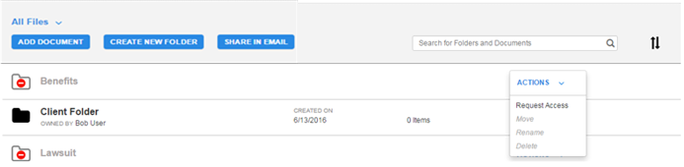

### Certificates Tab

If you have commercial lines policies with us and you use certificates you may see the certificates tab. The certificates in the list are called Master Certificates because they contain all the information that may be required by multiple certificate holders.

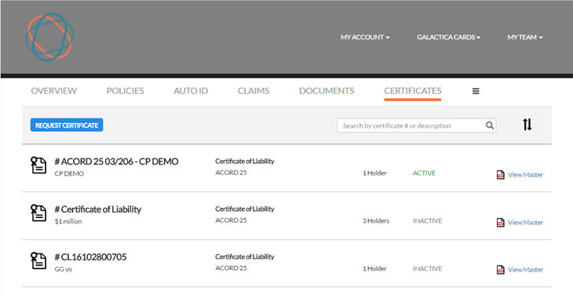

When you click a certificate in the grid, another web page opens showing all the current certificate holders. You can print an existing certificate, request a certificate for a new holder, or email a certificate.

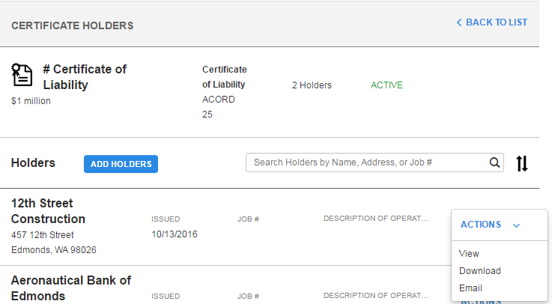

## Other Functions and Features of Client Portal

The Header includes important menus.

**Hi (username)**

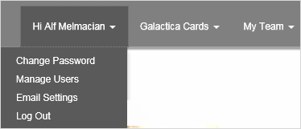

Here is where you can Change your Password, Manage Users, change your Email Settings, and Log Out. The Manage Users option allows you to add users who will have access to your Portal. When you click **Manage Users** you will see a list of Contacts that we’ve entered for your account. If you don’t see the name and email you’re looking for, contact our office and ask us to add the contact and email address. The Email Settings selection allows you to opt out of email confirmations for requests and submissions you‘ve made on the web site.

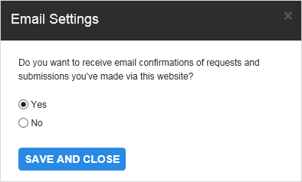

**My Team**

The information listed is the people in our agency responsible for your account. With this information so convenient, you can easily contact us if needed.

