AMS360 Classic to NextGen

AMS360 NextGen contains the functionality of Classic AMS360 with some new features. We provide this document to help you transition to the new look and feel of AMS360 NextGen. If you have questions on accessing a feature in AMS360, Online Help provides that information. Look for Help in the upper right corner of a Center, a question mark on a view, or on the menu bar in data entry forms.

The AMS360 Classic Reports are still available in NextGen and provide all the same functionality as before.

Contents
Center Names 3
Functionality 4
New Dashboard View in the Home Center 4
Editing your Agency, Banks, Brokers, Companies, Customers, Employees, and Vendors 5
Agency 5
Banks, Brokers, Companies, Employees, and Vendors 5
Customers 5
Menus 6
Classic Center Menu 6
NextGen Sidebar Menu 6
NextGen Quick Access Toolbar 7
Classic Toolbox Menu 8
NextGen 360 Toolbox Menu 8
New Administration Center 9
Classic Sales Center 10
Target Lists and Campaigns in NextGen 11
Leadlist Administration in NextGen 12
New Customer Setup 13

Center Names

The User Center has been renamed to the Home Center. The Sales Center is gone and the functions spread amongst other Centers. A new Center, Administration, has been added and the selections from the Toobox > System Administration menu are now located there.
Classic | NextGen
User | Home
Customer | Customer
Broker | Broker
Bank | Bank
Company | Company
Financial | Financial
Vendor | Vendor
Sales | Removed and functions moved to other Centers
Didn’t exist | Administration

Functionality

NextGen changes the look of all the AMS360 Centers, retains the functionality and adds new features as well. The User Center is now the Home Center and includes a new Dashboard view. You’ll also have a new access point in each Center for editing your agency setups, banks, brokers, companies, customers, employees, and vendors.

You’ll also see a change in viewing information in the Center and opening another screen. For example, the menu bar has been replaced with the Sidebar menu, the 360 Toolbox menu, and frequently used selections are now available on a Quick Access toolbar. The selections on the Sidebar menu change from Center to Center based on the Views, Actions, and Quick Reports available. In this way it works the same in NextGen as it did in Classic. The Quick Access bar is located in the upper right corner in each Center. The 360 Toolbox menu is located in the lower left corner or each Center.

New Dashboard View* in the Home Center

Features such as Favorite Links and the Message Center are now located on a Dashboard view in the Home Center. (See below) The Dashboard also includes a list of your Recent Customers with links to open the customers quickly without having to search for them. The Home Center includes the views you are familiar with, but were displayed as tabs in Classic AMS360.

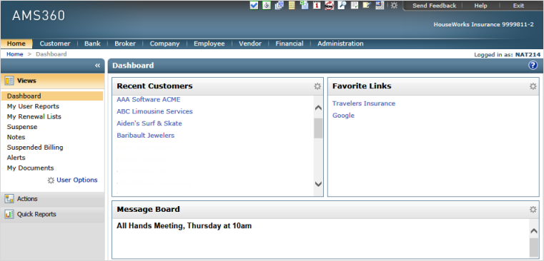

*If you use Vertafore Agency Platform, The opening page of Platform, My Agency Home, replaces the Dashboard View in AMS360.

Editing your Agency, Banks, Brokers, Companies, Customers, Employees, and Vendors

With NextGen you‘ll access the edit screens for each of these entities differently than you did in Classic.

Agency

To edit your Agency setups, open the new Administration Center. In the Sidebar menu find Agency Overview in the General section. When you select Agency Overview you’ll see Edit Agency in the upper left corner of the overview panel. Click the link to open Agency Setup.

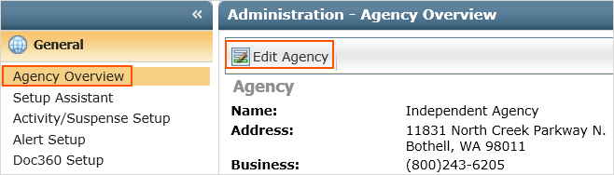

Banks, Brokers, Companies, Employees, and Vendors

Each of these Centers has a new selection in the Sidebar View menu called CENTER Overview. Click it and you’ll see an overview of the entity you have open. You’ll see an Edit CENTER in the upper left corner of the overview panel. Click the link to open the Setup screen.

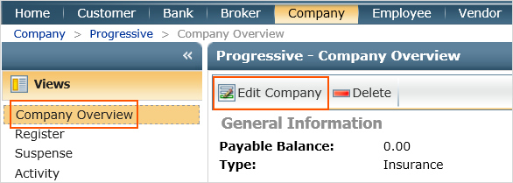

Customers

To edit customer information you can click Customer Overview in the View section of the Sidebar menu and then the Edit Customer link like the other Centers. In addition, you can click the Edit Customer link in the upper right corner of the Center, which is visible at all times while you’re in the Customer Center.

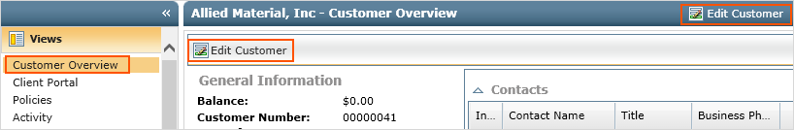

Menus

Classic Center Menu

The Center menu in Classic had selections specific to the Center.

NextGen Sidebar Menu

The new Sidebar menu includes Views, Actions, and Quick Reports for each Center. Views are the equivalent to Tabs in Classic. Having the Sidebar menu provides more space for each of the Views. More information displaying equals less scrolling.

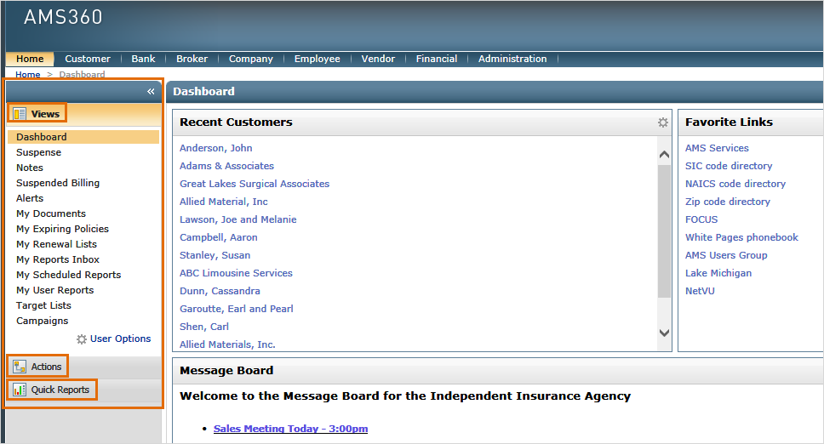

NextGen Quick Access Toolbar

A new toolbar with frequently used functions is available on every Center. The toolbar retains your settings no matter where you are. Use the Quick Access Options to customize your toolbar.
 | 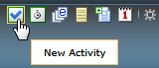  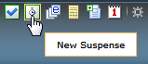 | 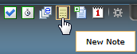  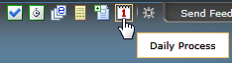  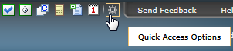
Classic Toolbox Menu  Many of the items on the Classic Toolbox menu have been moved to the 360 Toolbox menu. However, the areas under System Administration in Classic have been moved to the new Administration Center.  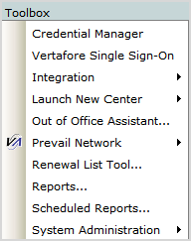 |  |  | NextGen 360 Toolbox Menu  A combination of selections from the Classic Toolbox menu, Center Menu bar, and new features. The 360 Toolbox menu is on the lower left corner of every Center.  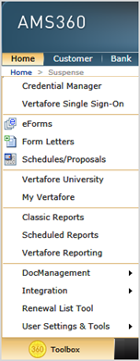

New Administration Center

The new Administration Center provides access to the tools features available previously on the Toolbox > System Administration menu. New features added in NextGen include Purge and Audit Trail.

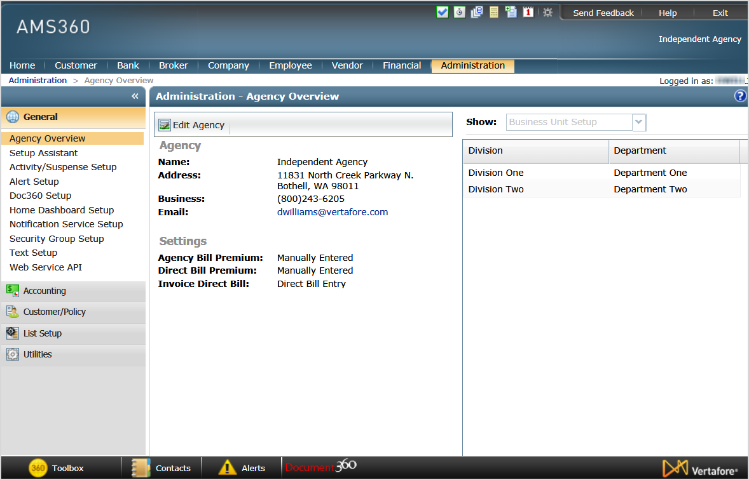

Classic Sales Center

The Sales Center is not a part of NextGen. The Center is gone and functionality has been moved to other Centers and the charts have been removed.

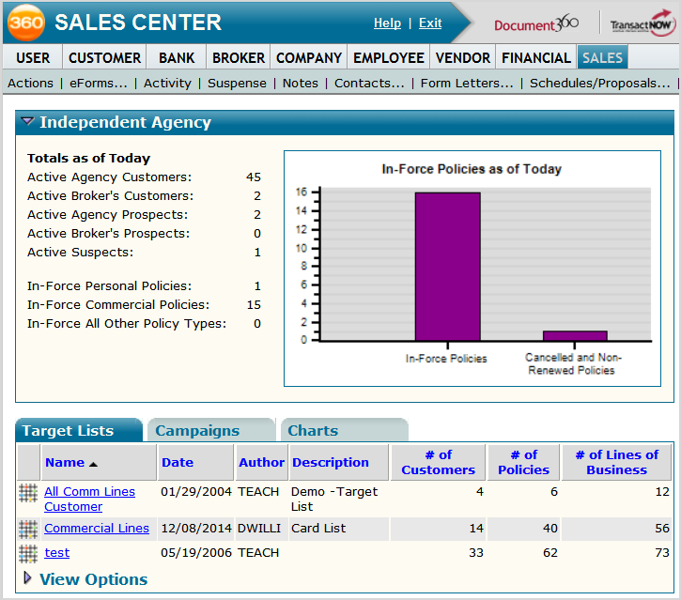

Target Lists and Campaigns in NextGen

You can view and create new Target Lists and Campaigns in the Home Center. Choose Target Lists or Campaigns under Views in the Sidebar menu. Functions when viewing Target Lists and Campaigns include:
Target Lists: View, New, Delete, and Form Letters*
Campaigns: View, New, Copy, Delete, and Manage Responses
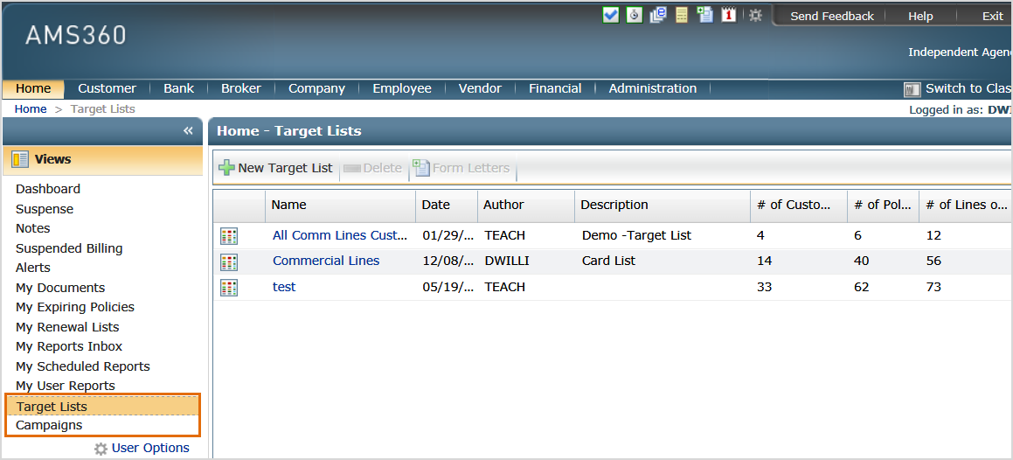

*The Form Letters selection in Target Lists provides an quick and easy way to merge a list with a form letter.

Leadlist Administration in NextGen

This feature has moved to the new Administration Center.
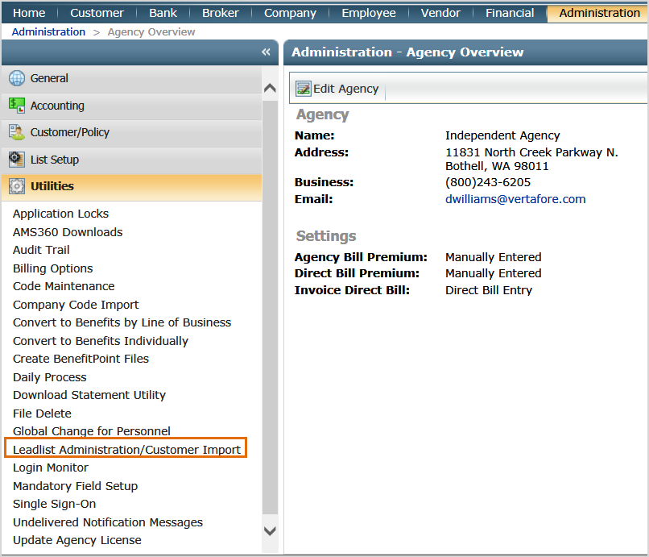

New Customer Setup

When you create a new customer, prospect, or suspect in NextGen, you’ll use new setup screens. The screens include all the same information. Instead of expanding sections on one screen, you’ll use the Form Sections navigation on the left side of the page.

